Project status report

REPORT DATE | COMPANY NAME | PREPARED BY
07/01/2025 | Fresh Beats | Manish Tandel

STATUS SUMMARY
The current analysis of user engagement trends across music genres reveals valuable insights for product and marketing strategies. Key findings indicate shifts in genre popularity, difference in user behavior between free and paid tiers and opportunities for user conversion and retention. The most notable trend is the growing popularity of electronic and hip-hop genres, contrasted with a decline in pop. Rock remains the leading genre among free-tier users and presents a promising conversion opportunity.

INSIGHT AND RECOMMENDATION
Insights:  - Pop genre peaked in 2021 and is on a downwards trend  - Electronic and hip hop music are overall on an upwards trend. |  |  | Visual A  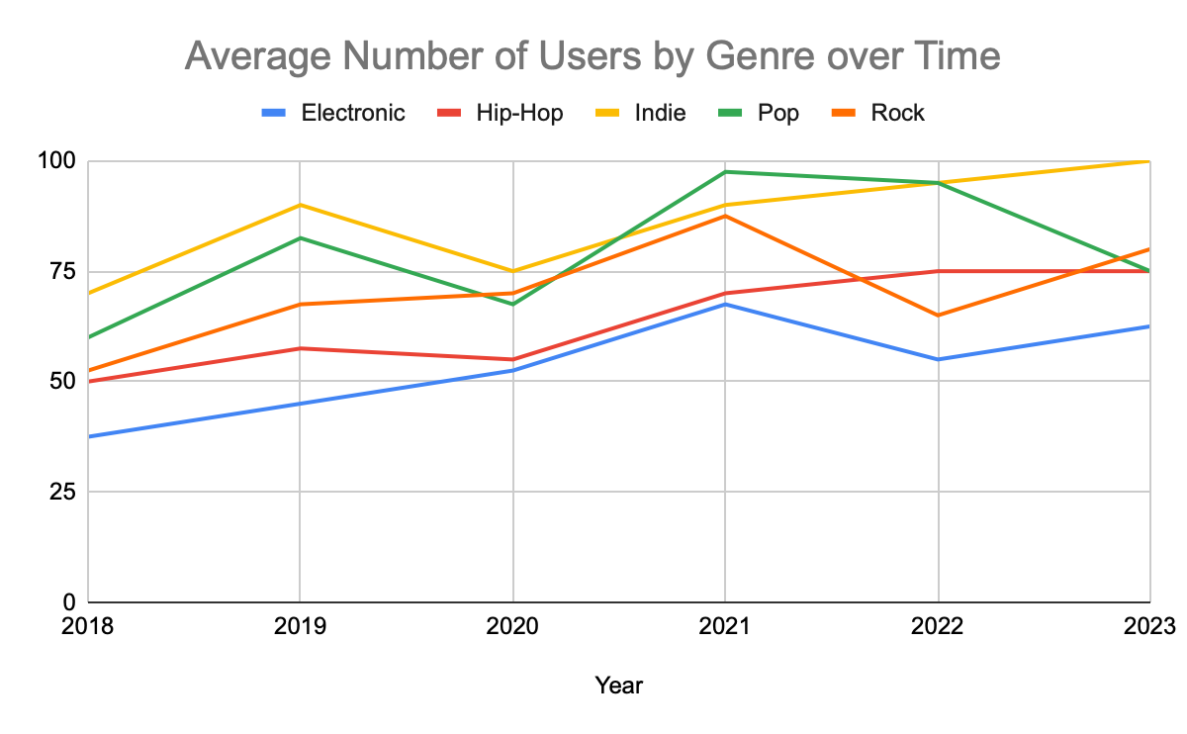
Recommendation:
- Marketing should try focused campaigns targeting typical demographics for fans of pop and rock genres.
- It is worth doing deeper research into previous years to understand why pop is on a downwards trend.
- We should analyze more ways to increase the engagement of rock-listening users, as a potential growth segment.

INSIGHT AND RECOMMENDATION
Insights:  - Paid users are more active (listen to more music) than free.  - Paid users have steadier growth and better user retention than free. |  |  | Visual B  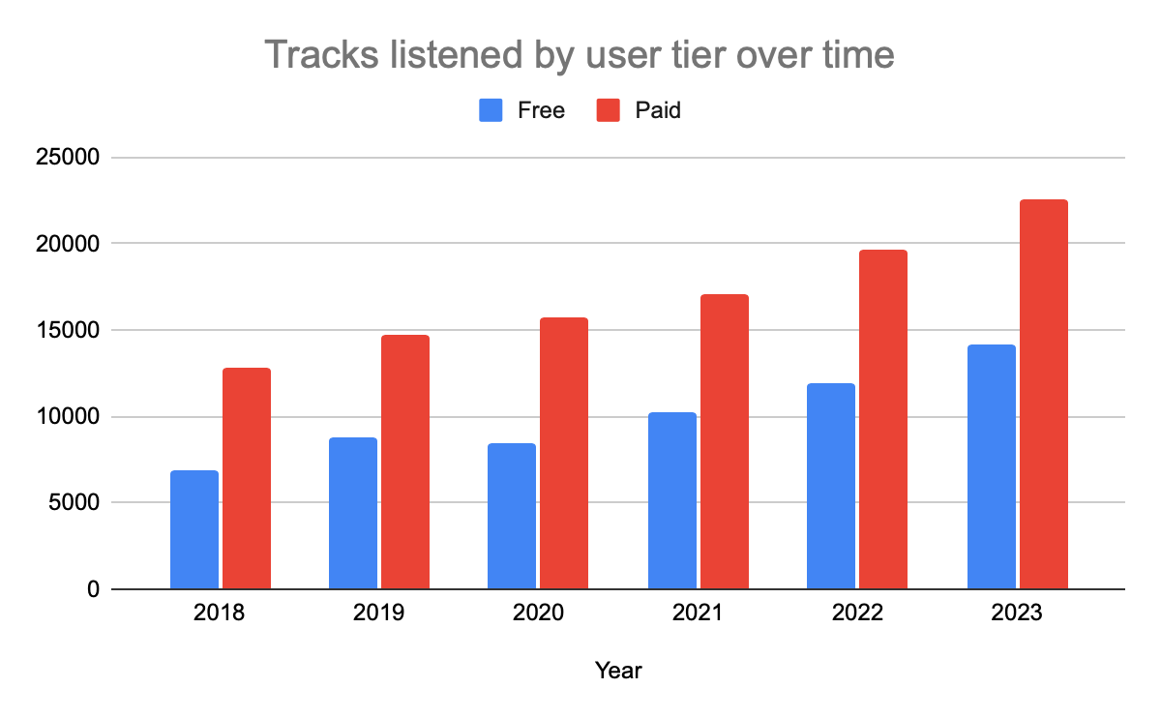
Recommendations:
- Consider intermediate tiers between free and paid, to make it easier to convert users from free to paid. (Something like Free first month trial)
- Offer users a referral marketing option, so they can get a free trial of the paid tier by referring new users.
- Paid users are very valuable, so it is worth offering time-limited promotions and other deals to convert users from free to paid.

INSIGHT AND RECOMMENDATION
Insights:  - Rock is the most popular genre for free users. |  |  | Visual C  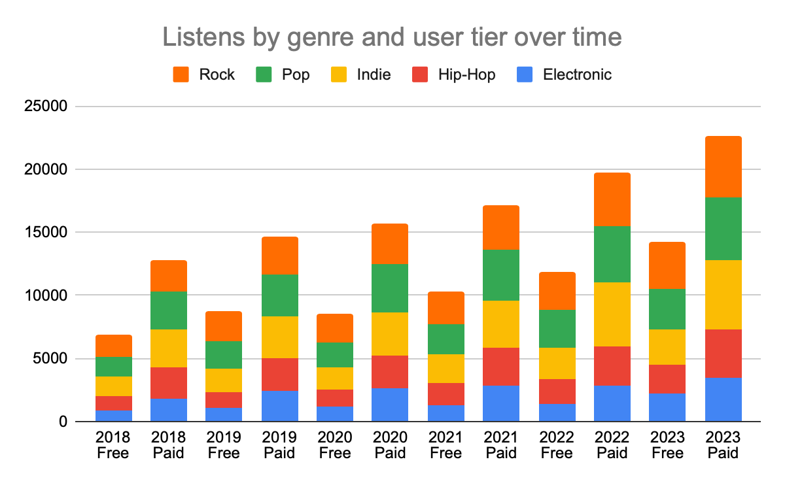
Recommendations:
- We should analyze user retention in Electronic and Hip-Hop genres, and consider how we can maximize it.
- Product/marketing teams should try experiments to generate leads in alternative genres.
- Try promotions focused on rock that offer free trials to convert to paid users.
- We should analyze more ways to increase the engagement of rock-listening users, as a potential growth segment.
- Indie is particularly popular with paid users, so focus promotions there.

CONCLUSION
- We should increase our catalogue of tracks in electronic and hip hop music - solicit appropriate artists and offer them deals (time-limited free promotion).
- Rock is the key genre for free users - we should experiment and research further to see how it can be leveraged to convert them to paid.

